Mayekar Technologies Pvt. Ltd.
Information Security Risk Register
ISO/IEC 27001:2022
Clause 6.1.2 & 6.1.3 Annex A Risk-Based Controls
Document Number
MTPL-ISMS-014
Version
1.0
Prepared By
Omkar Abhay Mayekar
ISMS Project Developer
Reviewed By
Alankar Abhay Mayekar
Information Security Manager
Approved By
Aakanksha Abhay Mayekar
Chief Executive Officer (CEO)
Classification
Internal Use Only
Effective Date
01 August 2026

Document Control
Field | Value
Document Name | Information Security Risk Register
Document Number | MTPL-ISMS-014
Document Version | 1.0
Document Owner | Information Security Manager
Prepared By | Omkar Abhay Mayekar – ISMS Project Developer
Reviewed By | Alankar Abhay Mayekar – Information Security Manager
Approved By | Aakanksha Abhay Mayekar – Chief Executive Officer (CEO)
Document Classification | Internal Use Only
Document Status | Approved
Effective Date | 01 August 2026
Approval Date | 01 August 2026
Next Review Date | 31 July 2027
Review Frequency | Annually or upon significant changes
Document Location | ISMS Repository
Document Retention Period | 7 Years
Distribution | Top Management, Information Security Manager, Risk Owners, Department Heads, Internal Auditors
Revision History | Version 1.0 – Initial Release

Document Confidentiality Statement
This document contains confidential and proprietary information of Mayekar Technologies Pvt. Ltd. and forms an integral part of the organization's Information Security Management System (ISMS). It contains information relating to identified information security risks, risk owners, risk treatment decisions, and security controls. Unauthorized access, disclosure, copying, modification, distribution, or use of this document is strictly prohibited without prior authorization from Top Management.

1. Purpose
The purpose of this Information Security Risk Register is to establish and maintain a centralized record of identified information security risks that may affect the confidentiality, integrity, and availability of organizational information assets. The Risk Register provides a structured mechanism for documenting identified risks, evaluating their likelihood and impact, assigning ownership, implementing appropriate risk treatment measures, and monitoring residual risks throughout the risk management lifecycle.
This document supports informed decision-making, effective allocation of security resources, regulatory compliance, and continual improvement of the Information Security Management System (ISMS). It is developed in accordance with the requirements of ISO/IEC 27001:2022, particularly Clauses 6.1.2 and 6.1.3, and supports the organization's risk-based approach to information security management.

2. Scope
This Risk Register applies to all information assets, business processes, supporting technologies, personnel, facilities, and third-party services that fall within the defined scope of the Information Security Management System (ISMS) of Mayekar Technologies Pvt. Ltd. It covers risks associated with cyber threats, human error, system failures, physical security, legal and regulatory compliance, supplier relationships, business continuity, and operational processes.
The Risk Register encompasses the complete information security risk management lifecycle, including risk identification, analysis, evaluation, treatment, ownership assignment, residual risk assessment, periodic monitoring, and management review. It serves as the organization's authoritative record for managing information security risks and supports continual improvement of the ISMS.

3. References
3.1 Purpose
The purpose of this section is to identify the standards, internal documents, and regulatory requirements referenced during the preparation and maintenance of the Information Security Risk Register, ensuring consistency, traceability, and compliance with the Information Security Management System (ISMS).
3.2 Reference Documents
Reference ID | Document / Standard | Purpose
REF-001 | ISO/IEC 27001:2022 | Information Security Management System Requirements
REF-002 | ISO/IEC 27002:2022 | Information Security Controls Guidance
REF-003 | Information Security Policy | Security Governance
REF-004 | ISMS Scope Document | Defines the ISMS Scope
REF-005 | Risk Assessment Methodology | Risk Assessment Process
REF-006 | Asset Inventory & Asset Register | Identification of Organizational Assets
REF-007 | Statement of Applicability (SoA) | Applicable Security Controls
REF-008 | Applicable Legal, Regulatory & Contractual Requirements | Compliance Obligations

4. Definitions & Abbreviations
4.1 Purpose
The purpose of this section is to establish a common understanding of the key terms and abbreviations used throughout the Information Security Risk Register to ensure consistency in risk identification, assessment, treatment, monitoring, and reporting.

4.2 Definitions
Term | Definition
Risk | The effect of uncertainty on business objectives that may impact information security.
Threat | A potential cause of an unwanted incident capable of exploiting a vulnerability.
Vulnerability | A weakness that can be exploited by a threat.
Risk Owner | Individual accountable for managing and monitoring an assigned risk.
Risk Treatment | The process of modifying a risk by implementing appropriate controls.
Residual Risk | The level of risk remaining after security controls have been implemented.
Risk Register | A controlled document containing identified risks, assessments, treatments, and monitoring information.

4.3 Abbreviations
Abbreviation | Meaning
ISMS | Information Security Management System
CIA | Confidentiality, Integrity and Availability
SoA | Statement of Applicability
KPI | Key Performance Indicator
KRI | Key Risk Indicator
IT | Information Technology
BCP | Business Continuity Plan
DR | Disaster Recovery

5. Risk Register Overview
5.1 Purpose
The purpose of this section is to provide an overview of the Information Security Risk Register and establish a structured framework for documenting, monitoring, reviewing, and managing information security risks throughout their lifecycle. The Risk Register serves as the organization's central repository for recording identified risks, supporting informed decision-making, and demonstrating compliance with the requirements of ISO/IEC 27001:2022.

5.2 Risk Register Overview
Mayekar Technologies Pvt. Ltd. maintains a centralized Information Security Risk Register to document all identified information security risks that may affect organizational assets, business processes, technology, personnel, facilities, or third-party services. Each identified risk is assigned a unique Risk ID, evaluated using the approved Risk Assessment Methodology, allocated to a Risk Owner, and monitored throughout its lifecycle.
The Risk Register supports effective governance by providing visibility into identified risks, existing controls, treatment actions, residual risks, implementation status, and review activities. It enables management to prioritize risks, allocate resources effectively, monitor treatment progress, and support continual improvement of the Information Security Management System (ISMS).
5.3 Objectives of the Risk Register
The Information Security Risk Register is maintained to achieve the following objectives:
- Maintain a centralized record of identified information security risks.
- Support consistent and repeatable risk assessment practices.
- Assign ownership and accountability for each identified risk.
- Record existing security controls and proposed risk treatment actions.
- Track residual risks after implementation of controls.
- Support regulatory, legal, and contractual compliance.
- Provide evidence for internal audits, external audits, and management reviews.
- Support continual improvement of the Information Security Management System (ISMS).
5.4 Risk Management Lifecycle
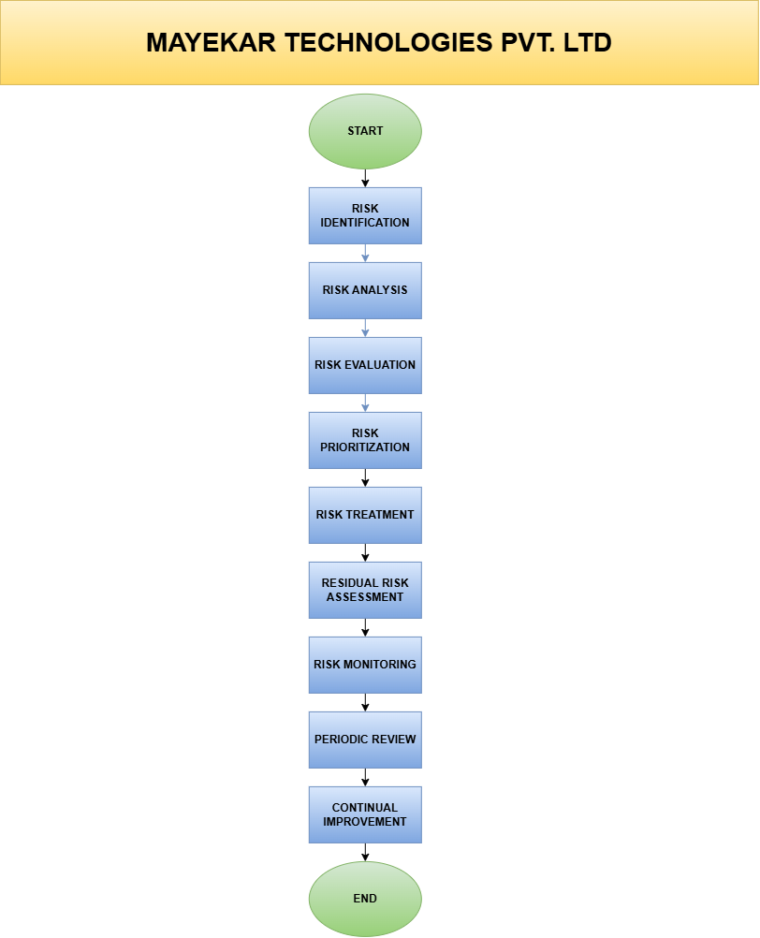
5.5 Risk Register Principles
The Information Security Risk Register shall be maintained as a controlled document and reviewed regularly to ensure that all identified risks remain accurate, current, and appropriately managed. All risk records shall include assigned ownership, documented risk assessments, treatment decisions, implementation status, and review history. Changes to risk information shall be authorized, documented, and communicated to relevant stakeholders in accordance with the organization's Information Security Management System (ISMS) and Document Control Procedure.

6. Risk Assessment Criteria
6.1 Purpose
The purpose of the Risk Assessment Criteria is to establish a consistent and objective framework for evaluating information security risks based on their likelihood of occurrence and potential business impact. This ensures that all risks are assessed, prioritized, and treated using a standardized methodology aligned with the organization's risk appetite and the requirements of ISO/IEC 27001:2022.

6.2 Risk Assessment Approach
All identified risks shall be assessed using the organization's approved 5×5 Risk Assessment Matrix. Each risk shall be assigned a Likelihood Rating and an Impact Rating. The Risk Score shall be calculated by multiplying the Likelihood Rating by the Impact Rating, and the resulting score shall determine the overall risk level and the required risk treatment approach.

6.3 Risk Rating Formula
Risk Score = Likelihood × Impact

6.4 Risk Level Classification
Risk Score | Risk Level | Required Action
1 – 4 | Low | Accept and monitor
5 – 9 | Medium | Implement Additional Controls
10 – 16 | High | Formal Risk Treatment Required
17 – 25 | Critical | Immediate Management Action Required

7. Information Security Risk Register
7.1 Purpose
The purpose of the Information Security Risk Register is to systematically record, assess, prioritize, and manage information security risks that may affect the confidentiality, integrity, and availability of organizational information assets. The Risk Register serves as the primary mechanism for documenting identified risks, assigning accountability, implementing appropriate risk treatment measures, monitoring residual risks, and supporting continual improvement of the Information Security Management System (ISMS).

7.2 Risk Register Process
All identified information security risks shall be recorded within the Risk Register using a standardized methodology. Each risk shall be assigned a unique Risk ID, linked to the relevant information asset, evaluated using the approved Risk Assessment Methodology, assigned to a Risk Owner, and monitored until the risk has been appropriately treated, accepted, transferred, or avoided in accordance with the organization's risk management process.

7.3 Risk Register Structure
The Risk Register shall include the following information for every identified risk:
Field | Description
Risk ID | Unique identifier assigned to each risk.
Asset | Information asset affected by the risk.
Threat | Potential event that could exploit a vulnerability.
Vulnerability | Weakness that may be exploited.
Existing Controls | Security controls currently implemented.
Likelihood | Probability of occurrence (1–5).
Impact | Business impact if the risk occurs (1–5).
Risk Score | Likelihood × Impact.
Risk Level | Low / Medium / High / Critical.
Risk Owner | Person accountable for managing the risk.
Risk Treatment | Planned action to reduce or manage the risk.
Residual Risk | Risk remaining after treatment.
Status | Open / In Progress / Closed / Accepted.
Review Date | Next scheduled review date.

7.4 Risk Register Principles
The organization shall ensure that:
- Every identified risk has a unique Risk ID.
- Every risk is linked to an information asset.
- Every risk has an assigned Risk Owner.
- Risk assessments follow the approved 5×5 Risk Assessment Methodology.
- Existing security controls are documented before determining additional treatment actions.
- Residual risk is evaluated after implementing treatment measures.
- The Risk Register is reviewed periodically and updated whenever significant changes occur.

7.5 Risk Treatment Options
All identified risks shall be managed using one of the following treatment options:
Treatment Option | Description
Mitigate | Implement security controls to reduce the likelihood and/or impact of the risk.
Accept | Accept the risk when it falls within the organization's approved risk appetite.
Transfer | Transfer the risk through insurance, outsourcing, or contractual agreements.
Avoid | Eliminate the activity or process that gives rise to the risk.

8. Information Security Risk Register (Excel Register)
The following Risk Register represents the identified information security risks applicable to Mayekar Technologies Pvt. Ltd. Each risk has been assessed using the approved 5×5 Risk Assessment Methodology, assigned to an appropriate Risk Owner, and linked to suitable treatment actions to ensure effective risk management and continual improvement of the ISMS.
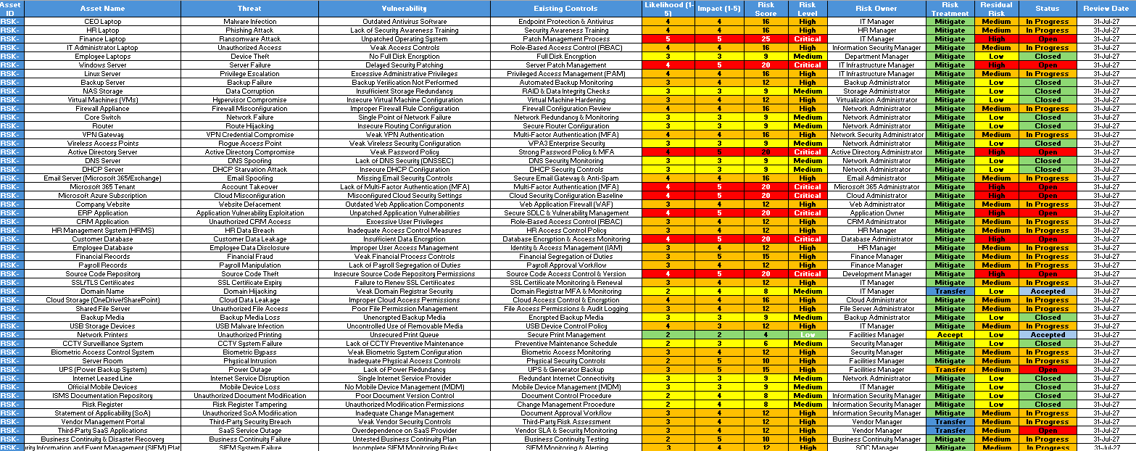

8.1 Purpose
The purpose of the Information Security Risk Register is to provide a structured and controlled record of identified information security risks, enabling the organization to evaluate, prioritize, treat, monitor, and review risks affecting its information assets. The register supports risk-based decision-making, accountability, and continual improvement of the Information Security Management System (ISMS).

8.2 Register Management
The Information Security Risk Register shall be maintained as a controlled document and updated whenever new risks are identified, existing risks change, treatment actions are completed, or periodic reviews are performed. Each risk entry shall be assigned a unique identifier, an accountable Risk Owner, and an appropriate treatment strategy in accordance with the organization's Risk Assessment Methodology.

8.3 Risk Register Fields
Field | Description
Risk ID | Unique identifier for each risk.
Asset | Information asset associated with the risk.
Threat | Potential event causing harm.
Vulnerability | Weakness that may be exploited.
Existing Controls | Controls already implemented.
Likelihood | Probability of occurrence (1–5).
Impact | Business impact (1–5).
Risk Score | Likelihood × Impact.
Risk Level | Low / Medium / High / Critical.
Risk Owner | Person responsible for managing the risk.
Risk Treatment | Mitigate / Accept / Transfer / Avoid.
Residual Risk | Remaining risk after treatment.
Status | Open / In Progress / Closed / Accepted.
Review Date | Next scheduled review date.

9. Review & Approval
Purpose
The purpose of the review and approval process is to ensure that the Information Security Risk Register remains accurate, relevant, complete, and aligned with the organization's information security objectives, risk appetite, and business requirements. Periodic reviews validate the effectiveness of risk assessments, treatment activities, ownership assignments, and residual risk evaluations, while formal approval demonstrates management commitment towards maintaining an effective Information Security Management System (ISMS).

Review Requirements
The Information Security Risk Register shall be reviewed under the following circumstances:
- At least once annually as part of the ISMS Management Review process.
- Following significant changes to business operations, organizational structure, technology, or information assets.
- After the identification of new information security risks or emerging cyber threats.
- Following the occurrence of major information security incidents or security breaches.
- When legal, regulatory, contractual, or compliance requirements change.
- After the completion of internal or external ISMS audits.
- Whenever significant risk treatment activities are completed or existing controls are modified.

Approval Authority
Role | Responsibility
Information Security Manager | Review the completeness, accuracy, and effectiveness of the Risk Register.
Department Heads | Validate risks related to their respective business functions and information assets.
Internal Auditor | Verify compliance with the Risk Assessment Methodology and ISO/IEC 27001:2022 requirements.
Chief Executive Officer (CEO) | Provide final approval for the Risk Register and authorize its implementation within the ISMS.

Review Frequency
Activity | Frequency
Risk Register Review | Annually
High & Critical Risk Monitoring | Quarterly
Risk Treatment Progress Review | Monthly
Management Review | Annually
Internal Audit Verification | Annually or as planned

10. Conclusion
The Information Security Risk Register serves as a fundamental component of the Information Security Management System (ISMS) by providing a structured and comprehensive record of identified information security risks affecting the organization. It enables management to evaluate risk exposure, prioritize treatment activities, assign ownership, monitor implementation progress, and maintain risks within the organization's defined risk acceptance criteria.
Through regular review, continual monitoring, and timely implementation of risk treatment measures, the Risk Register supports informed decision-making, strengthens organizational resilience, enhances regulatory compliance, and contributes to the continual improvement of information security practices in accordance with ISO/IEC 27001:2022.

